## Assignment for Week 8 Readings: (due Tues 8 Dec )

Eleanora, Gojko, Carlo, Enrico ([Contattaci: #week8 sul Slack](https://topicsinmulti-b5g1638.slack.com/archives/C02MX8E7GA3) )

Goal: Give everyone a basic introduction to intrinsic tactile sensing and to the issues that arise from tactile sensor data being somewhat noisy. This is part of the “Sim2Real” problem.

* [Link to Week 8 slides](https://docs.google.com/presentation/d/1rKTYinDRoJ-fgbsYly87Q_wVgV1LZGd1WPE8rrWXoIM/edit?usp=sharing)

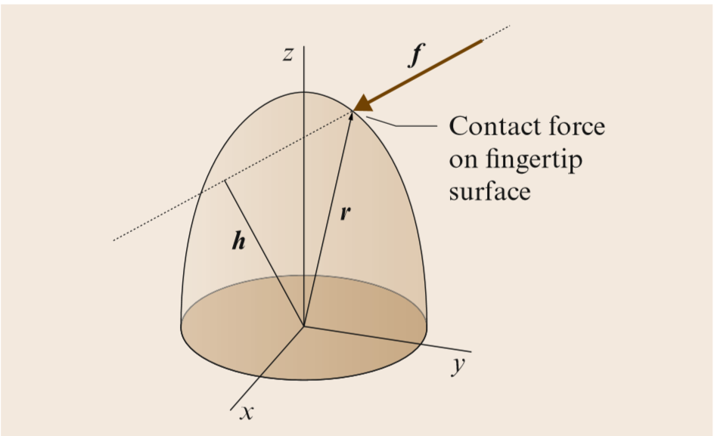

### Q1

Son, Cutkosky, and Howe did a [Comparison of Contact Sensor Localization Abilities During Manipulation](http://biorobotics.harvard.edu/pubs/1996/son_RAS1996.pdf) that we presented during class. (See also [Cutkosky & Provancher 2016](https://drive.google.com/file/d/1HTeVArj1I4_TsgRETFjjvXAbA7zwGNQP/view?usp=sharing))

This assignment gives you a chance to implement your own intrinsic contact sensing algorithm with a spherical fingertip and, more generally, to look at the “Sim2Real” problem, which is that tactile data tend to be noisy.

**Q1.1** The script, [**TMM_Week8_Q1_generator.py**](https://drive.google.com/drive/folders/1qAQm4RrRDluMe79AYcUElnPklcNz7b9W?usp=sharing) takes a given sequence of sliding contact forces that follow a trajectory on the surface of a hemispherical fingertip, as shown at right.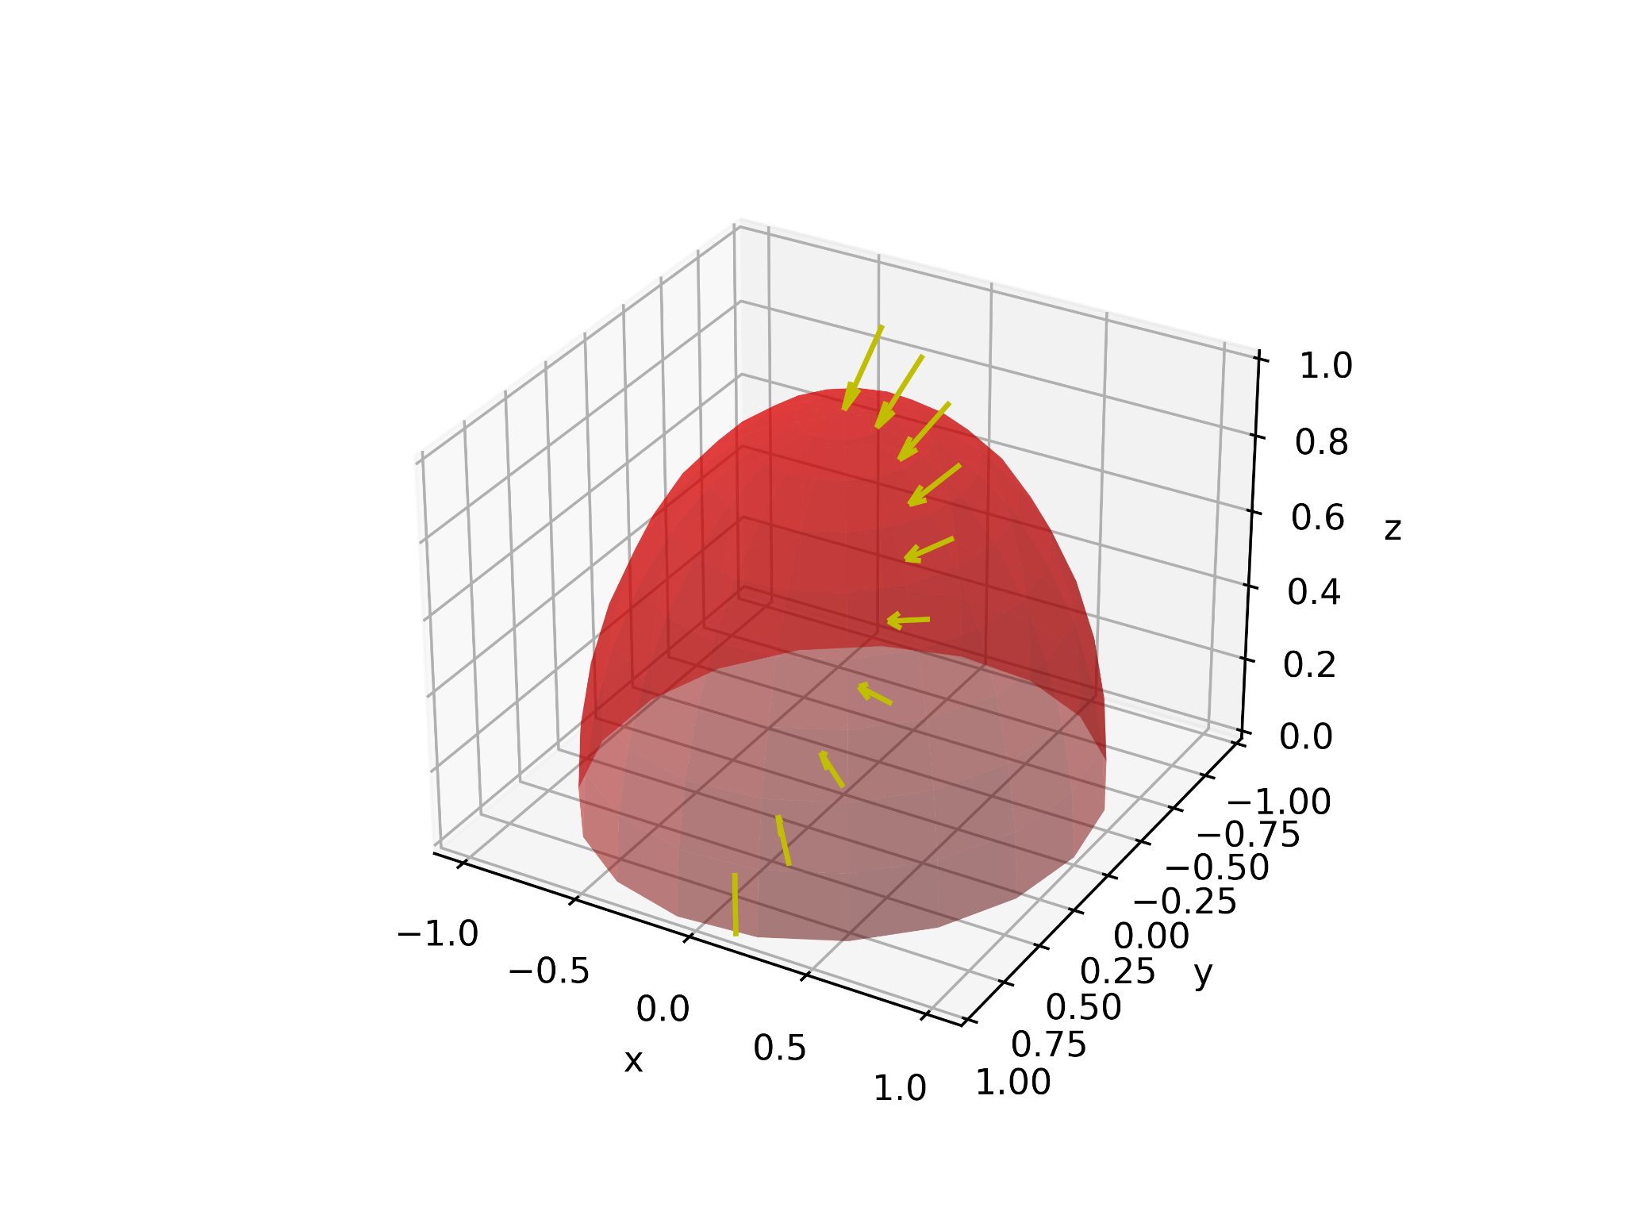

It computes the corresponding wrenches that would be measured by a 6-axis force/torque sensor at the origin of the hemisphere (e.g. if you added an [ATI Nano sensor](https://www.ati-ia.com/products/ft/ft_models.aspx?id=Nano17) to a finger on the [Allegro hand](https://www.wonikrobotics.com/research-robot-hand)) and writes the data to a tab-delimited text file, ‘**wrench-sequence.txt**’, which can be read by Python, Matlab or even a spreadsheet program. Construct your own intrinsic contact sensing (ICS) solution to read the wrench data and then recreate the input contact force trajectory. If your program is working correctly it should be able to recreate a matrix equivalent to **‘plotvec’** in the generator script, where each row is a new contact location and corresponding force data: [x,y,z,fx,fy,fz].

**Q1.2** The script also writes a second file, ‘**noisy-wrench-sequence.txt**’, with the same wrench data, to which 5% normally distributed random noise has been added. This is probably a realistic expectation from the force/torque sensor given both electrical noise and the fact the there will be vibrations and perhaps some stick/slip sliding. Run your same intrinsic tactile solution on this data and look at the result. How easily can you determine the likely sliding contact force trajectory from this data? (This is a qualitative question.)

**Q1.3** Note, by the way, that this noisy simulation might not even represent the worst case scenario. *What happens if the the fingertip briefly looses and then regains contact with whatever is sliding on it?*